|  |  |  |
| --- | --- | --- |
| Sprint review - **Increment Two** **dELIVERY** | | |
|  | | |
| **Location:** | Google Meets |  |
| **Date:** | October 16, 2020 |  |
| **Time:** | **9:00 PM** |  |
| **Facilitator:** | Baheshta Abed |  |

# Attendees:

Mashall Addeel, Sayed Manshour Sadat, Masuoma Tajik and Mahdi Alizada.

**Meeting Purpose:**

The purpose of this meeting was for the Development Team to present the second increment for the Product Owner to either approve or reject or give feedback for any changes.

**Below are the events that took place in the meeting:**

The meeting took place in the event as the previous increment delivery meeting with the Scrum Master welcoming everyone, followed by the Masouma from the Development Team, presenting the project they have worked on to the Product Owner.

|  |  |  |  |  |  |
| --- | --- | --- | --- | --- | --- |
| **Tasks** | **Hours** | **Day 1** | **Day 2** | **Day 3** | **Day 4** |
| Design and create a "list-view" in the interface | 4 | 4 |  |  |  |
| Create and design notification systems | 4 | 2 | 2 |  |  |
| Create a Quick Search option for retrieval of books | 4 |  | 4 |  |  |
| Enhance the Quick Search Option by adding more relevant features based on the information of the books | 4 |  |  | 4 |  |
| Include an Edit Option for the users as well as the books | 4 |  |  | 2 | 2 |
| **Total Hours:** | **20** | **6** | **6** | **6** | **2** |

During the Sprint, the Scrum Master did conduct Daily Sprints via Facebook Messenger, in order to keep a track of the tasks being done accurately based on the Product Owners’ demand (i.e. the user stories). Below are the Sprint Backlogs as well as the Burn Out Chart for the second Sprint.

Burn Out Chart

|  |  |  |  |  |  |  |
| --- | --- | --- | --- | --- | --- | --- |
|  | **Day 0** | **Day 1** | **Day 2** | **Day 3** | **Day 4** | **Day 5** |
| **Estimated Effort** | 20 | 16 | 12 | 8 | 4 | 0 |
| **Actual Effort** | 20 | 6 | 6 | 6 | 2 | 0 |

**Sprint Backlogs** were updated every day throughout the Sprint.

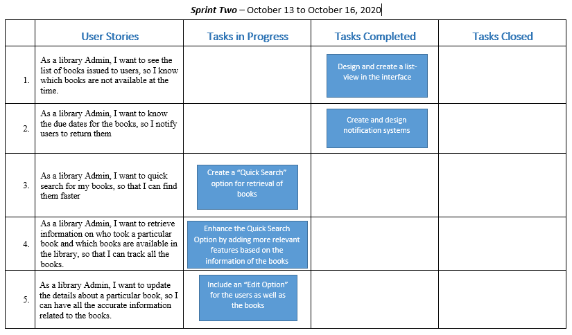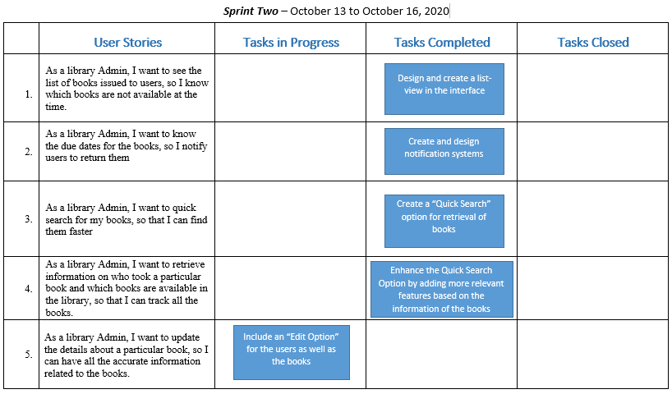

Day 1 of Sprint 2

Day 3 of Sprint 2

After the team presented their project the Product Owner, after checking the system her according to her requirements, was yet again pleased with the work of the Development Team. She was impressed with their approach of working together in one task at a time, which helped them to work more accurately and efficiently as compared to working separately on separate tasks. Once again, the Product Owner was pleased with the outcomes of the increment and requested the team to proceed with the next increment. The Product Owner asked the Development Team to deliver the next increment (i.e. the third increment) on October 20, 2020.